IJMDES Manuscript Template
First Author¹, Second Author², Third Author³
¹Designation, Department, Organization, City, Country
²Designation, Department, Organization, City, Country
Abstract: These instructions give you guidelines for preparing papers for IJMDES Journal. Use this document as a template to prepare your paper. Copy and paste the content to prepare the paper.

Keywords: Enter key words or phrases in alphabetical order, separated by commas.

Introduction
The document starts here. Copy and paste the content in the paragraphs.
The section title also can be copied and paste it, when you need new section and type the section heading as per your requirement.

Guidelines

Subsection
The above section says how to prepare a subsection. Just copy and paste the subsection, whenever you need it. The numbers will be automatically changes when you add new subsection. Once you paste it, change the subsection heading as per your requirement.

Sub Subsection
If you have a sub subsection, then copy and paste the sub subsection heading and modify the heading.
If you have more sub points you can use as per the requirement.
- Numbering
- Bullet points
You can use any style for points.

Table
If you have a Table, simply paste it in the box provided below and adjust the table or the box. If you adjust the box, you can keep the table in single column, if you have long table.
Table 1
Table title comes here

Figures
If you have a figure, simply paste it in the template and adjust the size of the figure as per the requirement.
Then add the figure caption, as Fig. 1. Title of the figure with 8 pt. size. An example is given as follows,

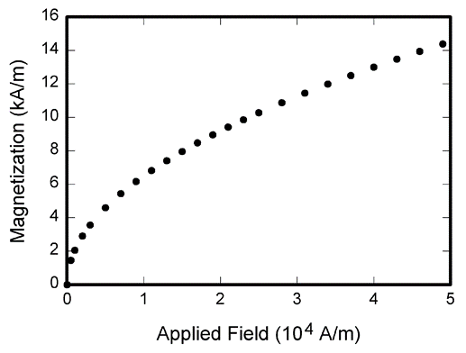
Fig. 1. Title of the figure with 8 pt. size

About references
The [1], [2] styles say how to cite a journal paper, [3], [4] styles say how to cite a conference paper, [5], [6] styles say how to cite a text book, [7], [8] styles say how to cite a thesis. If you have any other references like websites etc., you can keep it in any style.

References
- J. K. Author, “Name of paper,” Name of the Journal, vol. x, no. x, pp. xxx-xxx, Abbrev. Month, year.
- J. U. Duncombe, “Infrared navigation—Part I: An assessment
of feasibility,” IEEE Trans. Electron Devices, vol. ED-11, no. 1, pp. 34–39, Jan. 1959.
- J. K. Author, “Title of paper,” in Abbreviated Name of Conf., City of Conf., Abbrev. State (if given), year, pp. xxxxxx.
- D. B. Payne and J. R. Stern, “Wavelength-switched pas- sively coupled single-mode optical network,” in Proc. IOOC-ECOC, 1985,
pp. 585–590.
- J. K. Author, “Title of chapter in the book,” in Title of His Published Book, xth ed. City of Publisher, Country, USA: Abbrev. of Publisher, year, ch. x, sec. x, pp. xxx–xxx.
- G. O. Young, “Synthetic structure of industrial plastics,” in Plastics, 2nd ed., vol. 3, J. Peters, Ed. New York: McGraw-Hill, 1964, pp. 15–64.
- J. K. Author, “Title of thesis,” M.S. thesis, Abbrev. Dept., Abbrev. Univ., City of Univ., Abbrev. State, year.
- J. O. Williams, “Narrow-band analyzer,” Ph.D. dissertation, Dept. Elect. Eng., Harvard Univ., Cambridge, MA, 1993.

